RAG - Ingestion
Step 1:
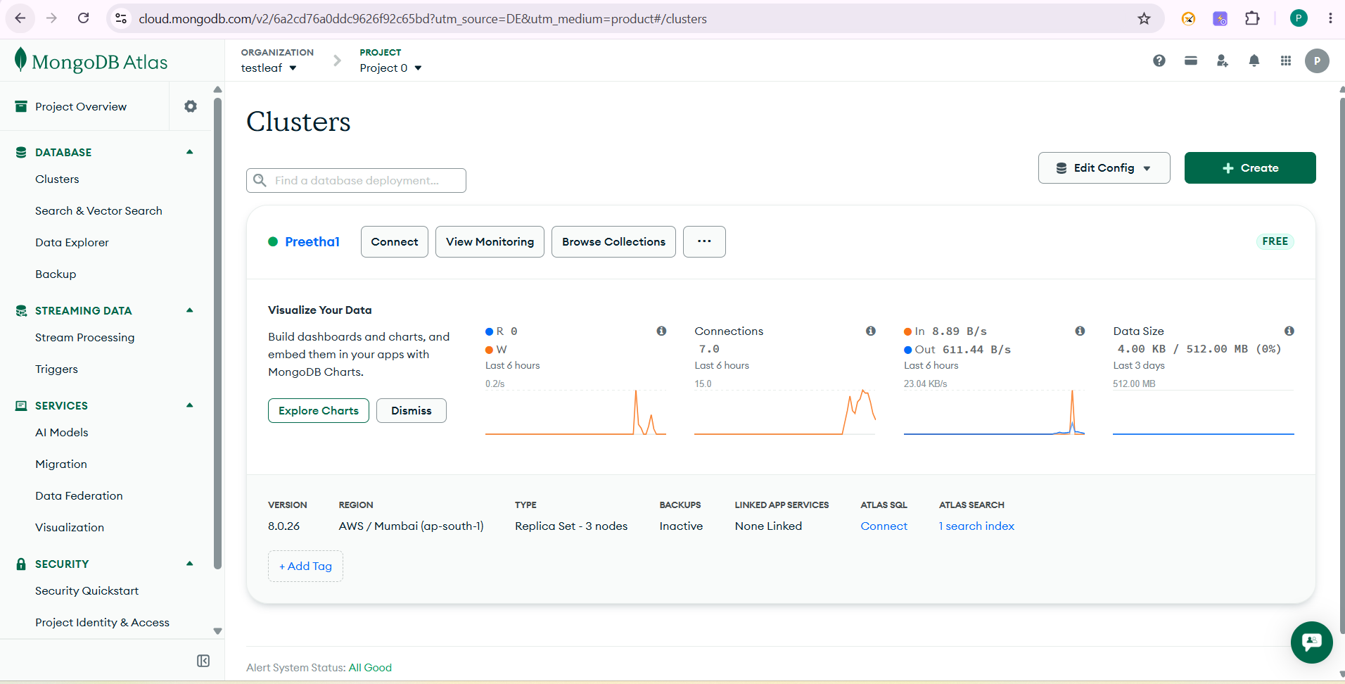
Step2: Create a DB user
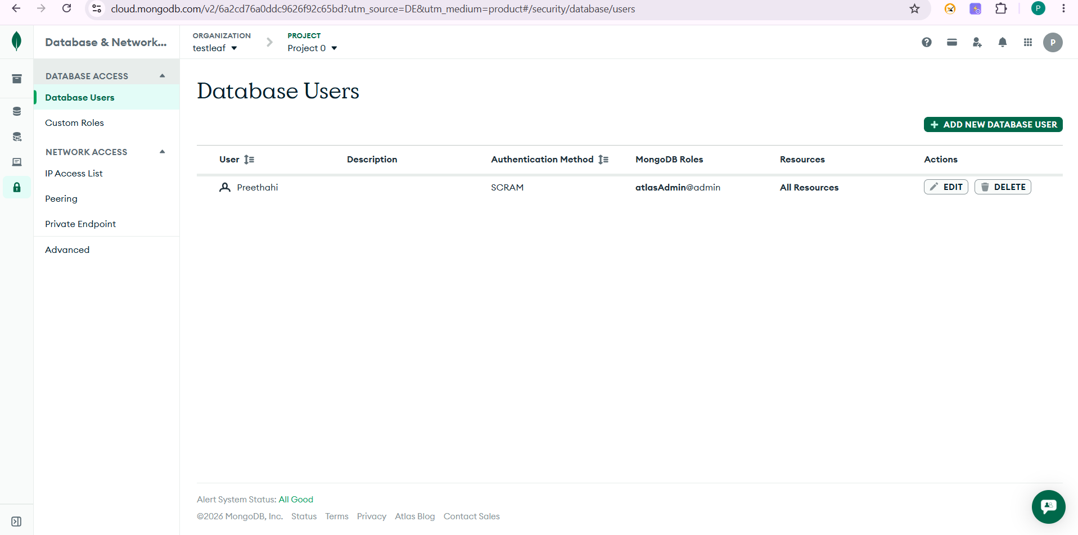

Step3: Include 0.0.0.0/0 in “IP Access List”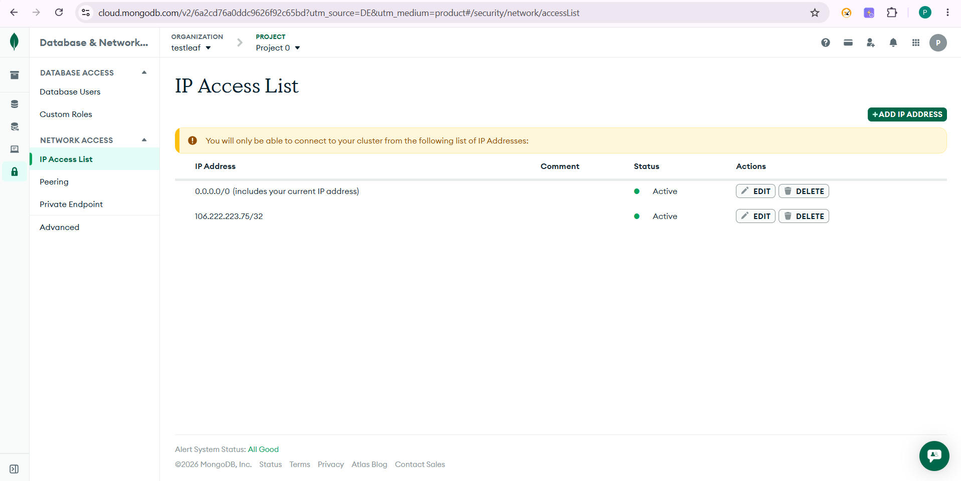
Step 4: Create a vector search
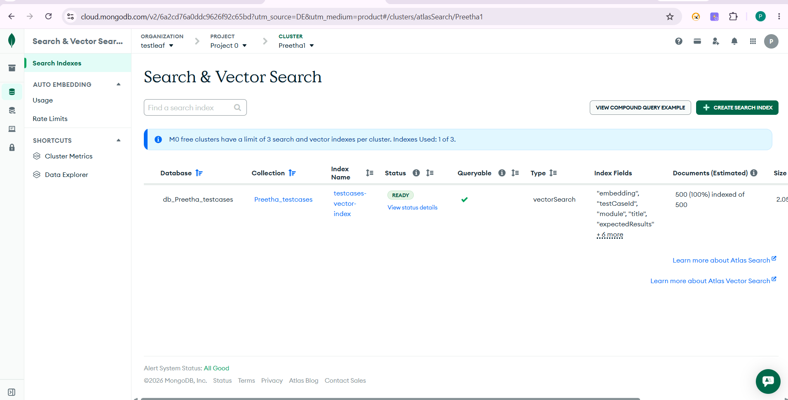

Step 4: Create a Langflow flow
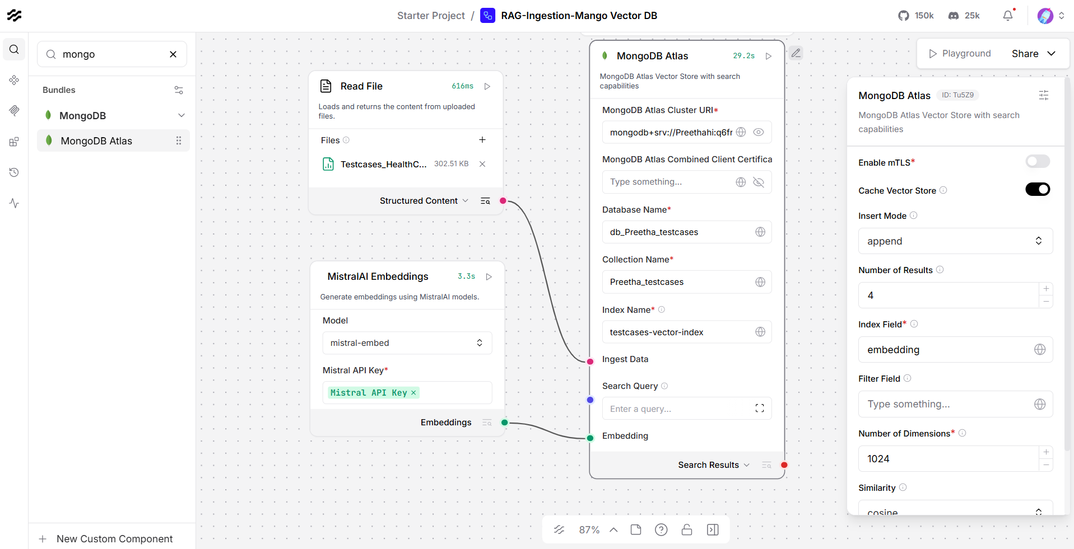
Step 5: 100 testcase are generated in the DB.
